
INDIAN SCHOOL AL WADI AL KABIR
Class: XII Comp. Sci. | Department: Computer Science | Date of submission:08.09.25
Worksheet No: 07 | Topic: MYSQL- DDL & DML | Note: Execute the queries on SQL

1 | Write the difference between WHERE and HAVING in SQL? Explain with examples
2 | Write SQL commands for the following queries from (a) to (d) based on the relations Stationery and Consumer given below:  Table : Stationery Table : Consumer  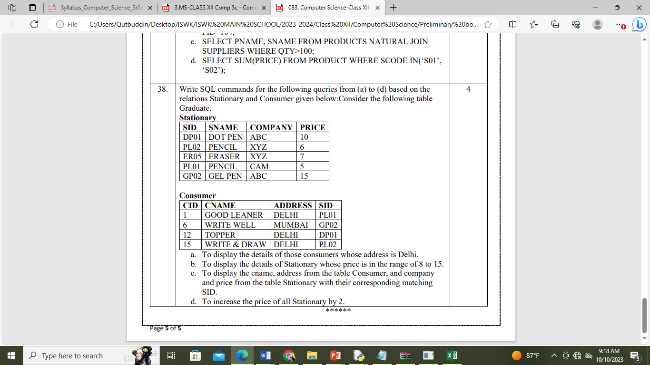  - To display the details of those consumers whose address is Delhi.  - To display the details of Stationery whose price is in the range of 8 to 15.  - To display the cname, address from the table Consumer, and company and price from the table Stationery with their corresponding matching SID.  - To increase the price of all Stationery by 2.
3 | A relation named Employee is given here, you can see the structure of relation. Solve the following query based on below given structure of relation.  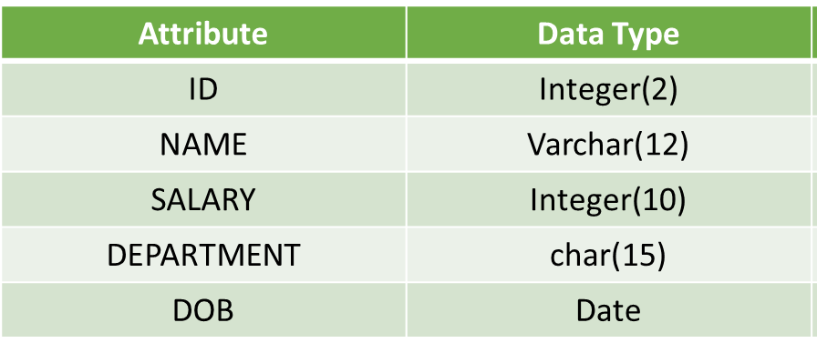  - Add one column into employee relation for storing department id of an employee.  - Write a query to change the data type of department to varchar with size of 20 and it should be NOT NULL.  - Write a query to make your ID column as a primary key.  4.Write a query to drop Department Id column.  5. Write a query to update the name of employee with ID number 2 to “SHRAVAN KUMAR”.  6. Write a query to delete the information of Production department.  9. Write a query to drop the employee relation.
4 | Consider the following relation named TEACHER and answet the questions:  - To display all information about the teacher of PGT category.  - To list the names of female teachers of Hindi department.  - To list names, department and date of hiring of all teachers in ascending order of date of joining.  - To count the number of teachers in English department.  - Display the department and hire date of all the female teachers whose salary is more than 25000.  - Display the list of teachers whose name starts with J.  - Display the total salary of female teachers from Hindi department.  - Display the maximum, average, minimum and total salary of teacher department wise.  - Display the department wise average salay of those department where more than 2 teachers are working.  - Display the sum of salary of teacher who have joined after ‘1990-01-01’.  - SELECT COUNT(*) FROM TEACHER WHERE CATEGORY=’PGT’  - SELECT AVG(SALARY) FROM TEACHER GROUP BY GENDER.
  ID | NAME | DEPARTMENT | HIREDATE | CATEGORY | GENDER | SALARY
  1 | Tanya Nanda | Hindi | 1994-03-17 | TGT | F | 25000
  2 | Saurabh Sharma | Art | 1990-02-12 | PRT | M | 20000
  3 | Nandita Arora | English | 1980-05-16 | PGT | F | 30000
  4 | James Jacob | English | 1989-10-16 | TGT | M | 25000
  5 | Jaspret Kaur | Hindi | 1990-08-01 | PRT | M | 22000
  6 | Disha Seghal | Math | 1980-03-17 | PRT | F | 21000
  7 | Sonali Mukherjee | Math | 1980-11-17 | TGT | F | 24500
5 | Create the following table structure. Table : TOYS  Column_Name DataType(size) Constraint  Toy_no Int(10) Primary Key  Toy_name Varchar(20) Unique  Toy_Type Char(10)  Price Integer Not null  Colour Varchar(15)  Write the following queries:  - Delete the details of toys for which type is Medium.  - Increment the price of all ‘Red’ colour toy by Rs. 200.  - Increment the price of all ‘Green’ colour toy by 5%.  - Decrement the price of the toy ‘Teddy’ by 3%  - Decrement the price by Rs. 50 for all the toys priced more than 500.  - Display the toy details in the Descending order of Price.  - Delete the details of the toys with the Toy Number 0004.  - Delete the details of the toys with the price less than 2000.
  Toy_no | Toy_name | Toy_Type | Price | Color
  001 | Spider man | Small | 1000 | Red
  002 | Barbie Doll | Small | 900 | green
  003 | Dominos | Medium | 1500 | Brown
  004 | Chess | Big | 2000 | Black
  005 | Car | Big | 25000 | Red
  006 | Teddy | Medium | 1500 | Pink
6 | Consider the table EXAM given below. Write commands in MySql for (i) to (iv)  Table: EXAM  - To count the number of students, who have either Accounts or Informatics as Subject.  - To insert a new row in the table EXAM:  6, “Mohan”, 500, “English”, 73, “SECOND”;  (iii) To count the number of students according to their Subject.
  No. | Name | Stipend | Subject | Average | Division
  1 | Karan | 400 | English | 15 | FIRST
  2 | Aman | 680 | Maths | 24 | FIRST
  3 | Javed | 500 | Accounts | NULL | FIRST
  4 | Bishakh | 200 | IP | 20 | SECOND
  5 | Sugandha | 400 | History | 10 | THIRD
  6 | Suparna | 550 | Geo | 5 | THIRD
  7 | Ankit | 400 | NULL | 10 | THIRD
7 | Write SQL Commands for (a) to (e) on the basis of table:  Table: FURNITURE  - To show all the information about the Baby cots from the furniture table.  - To list the itemname which are priced at more than 15000 from the furniture table.  - To list itemname and type of those items, in which dateofstock is before 2002-02-01 from the furniture table in descending order of itemname.  - To display itemname and dateofstock of those items, in which the discount percentage is more than 25 from the furniture table.  - To count the number of items, whose TYPE is “Sofa” from the furniture table.  - To display the item name that contains letter “o”  - To update price of the furnitures by 300 whose price is more than 10000  - Add a column item_code to the furniture table.
  NO | ITEM NAME | TYPE | DATEOFSTOCK | PRICE | DISCOUNT
  1 | White Lotus | Double Bed | 2002-02-23 | 3000 | 25
  2 | Pink feathers | Baby Cot | 2002-01-29 | 7000 | 20
  3 | Dolphin | Baby Cot | 2002-02-19 | 9500 | 20
  4 | Decent | Office Table | 2002-02-01 | 25000 | 30
  5 | Comfort zone | Double Bed | 2002-02-12 | 25000 | 30
  6 | Donald | Baby cot | 2002-02-24 | 6500 | 15
  7 | Royal Finish | Office Table | 2002-02-20 | 18000 | 30
  8 | Royal tiger | Sofa | 2002-02-22 | 31000 | 30
  9 | Econo sitting | Sofa | 2001-12-13 | 9500 | 25
  10 | Eating Paradise | Dinning Table | 2002-12-19 | 11500 | 25

